**Compify**



**Online Computing Courses Platform**

**Made for Seniors**

**Student Names:** Christos Koutsiaris & Mark Carley

**Lecturers:** Patricia O’ Connor & Anne Gannon

**MSc in Enterprise Software Systems**

# **Table of Contents**

**Table of Contents** 2

**1.0 Disclaimer & Document Audience** 3

**2.0 Abstract** 4

**3.0 Introduction** 5

**4.0 Goals** 5

**5.0 Target Audience** 6

**6.0 User Research** 7

**7.0 Competitor Analysis** 7

**8.0 Analysis of requirements** 8

**9.0 Scope of the project** 10

**10.0 MVP (Minimum viable product)** 11

**11.0 Usability** 11

**12.0 Personas & Scenarios** 12

**13.0 Style Tile** 13

**14.0 Wireframes - Low fidelity** 14

**15.0 Functional prototype - WIX** 15

**16.0 Evaluation** 15

**17.0 Discussion** 15

**18.0 Future Development** 17

**19.0 Conclusions** 18

**20.0 Appendices** 19

**21.0 References** 37

# 

# **1.0 Disclaimer & Document Audience**

*This document has been developed for Practical Assessment of the User Experience & Design module within the MSc in Computing (Enterprise Software Systems) program.*

*Specific parties interested in this scope document include:*

|  |  |
| --- | --- |
| * *P. Connor* * *A. Gannon* |  |

*This document has been created by team Group D. The members of this team are:*

|  |  |
| --- | --- |
| * *Mark Carley* * *Christos Koutsiaris* |  |

# 

# 

# 

# 

# 

# 

# 

# 

# **2.0 Abstract**

# 

This project aims to create an e-learning website for an audience targeted between the age of fifty and seventy years old. The given topic we are focusing on is “How to build a computer”. The goals of this website are to explain the steps of building a computer and also to learn how to fix common computer errors. This will be achieved with the help of the online courses provided and by following the step-by-step guides.

The plan of action to the workload of this brief is split everything in half so having one person do the user research & competitor analysis while the other focuses on user requirements. For the actual site to be developed in WIX, one team member will have worked on the desktop version and the other team member does the mobile version.

The main outcome of this project is having a functional and easy to follow e-learning site which will allow users to see the available courses, login / register, add a course to their profile and start learning. The site will have three main courses of content, first one would be a gentle introduction to hardware and how to assemble a computer, a second course about operating systems and software and a third about social media fundamental. All of them will have a common module on how to fix common computer issues.

# **3.0 Introduction**

The task we are given is to design and implement an online learning website which focuses on building a computer and any common problems associated with it. The product is aimed at age groups between 50 and 70 years old and to help people become more confident using digital devices, desktops and laptops going forward. The main importance of our chosen project is to create an easy to operate and simple to follow approach on having a better understanding of computers overall.

As a brand name we chose to use the word “Compify” which is short, easy to remember and pronounce.

When designing our website, we took into consideration the widely accepted Gestalt principles (Todorovic, 2008) and we tried to follow most of the Nielsens Heuristics (Nielsen, 1994). From the first days of the project, we followed a user centered approach by sending out online surveys. The responses we got back from users helped us in shaping the structure and design of Compify. Through multiple user-research studies we have been able to optimize features and sections of the website and finally making it an attractive solution for our future users.

# 

# **4.0 Goals**

The main goals of this project were to inspire and educate seniors about computing, in an easy and meaningful way, to provide great user experience by designing a delightful interface and finally build a high-fidelity working prototype that’s simple to use and easy to follow along with proposed learning paths that a user can choose to take. A more specific goals list as follows:

* Learn about our target audience through online research and interviews. Get feedback through the use of surveys in order to successfully design courses targeted at our audience.
* Find out who the competitors for our project are and compare what content they have by researching online.
* Find what our user requirements are and filter them in order to achieve in the given timeframe the most of the requested.
* Create user personas that represent the average user of our website so that we better understand who we are designing for and remind us who is the final user.
* Write a number of scenarios so that we have a better understanding on how the users might interact with our product.
* Develop a sitemap to finalize the paths of our website.
* Design wireframes with the help of various online tools, such as Miro, (Miro, 2021) Invision (Invision, 2021) and make them interactive so that we visualize how the website would look like.
* Design a style tile so that it is easy to communicate with the stakeholders the visual aspects of our project. Also, use the style tile as a reference during the development so that we achieve the desired consistency. The style tile would include at a minimum the following elements: Color theme, typography, a few simple components such eg. button, checkbox and iconography.
* Mockups and prototypes using WIX (WIX, 2021) to create versions of the website to test various features and course content.

For the final e-learning website, we aim to have at least, a home page, a courses page, a contact page, an about us page and a login/registration section. The courses page will be split into learning paths (sections) under hardware, software and social media. Each path will contain a number of modules specific to the subject and a common one with generic knowledge.

# 

# **5.0 Target Audience**

The target audience as per the requirements for this project is male and female users between the age of 50 and 70 years old. While we heavily focused our design on this group of users, we made sure that also users from any other group can use the platform efficiently.

Working for this target audience was an exciting opportunity because this is an age group that is growing rapidly worldwide as a share of total population (ScienceDirect, 2016). While computing technology became widely available and accessible to the masses in the last 30 years, we have to recognize that there is a big part of the older adult population who aren’t as comfortable or familiar with technology in general or at least not as much as they want.

As people age, several changes commonly happen to their senses. Many people of this age group use reading glasses and generally it becomes harder for them to see things (K Y Loh, 2004). The ability to learn new things is reduced, keeping concentrated for long periods is more difficult and even controlling parts of the body such hands might have an impact. These are some of the things that we took into consideration during the design phase.

# **6.0 User Research**

Our user research started by analyzing the product requirements as have been set by the product owners. Based on this analysis, we started researching the needs and goals of our target group users and more specifically on gathering data related to the age group that we are focused on. Because both of us don’t belong to this age group it was important to spend some time with seniors and by asking questions relevant to the project, first to observe their reactions and then strive to understand their mental model.

* Unfortunately, during the pandemic, it was very difficult to conduct as many interviews as we wanted and to be at the same space during the interview process. However, we managed to talk online to 4 adults via video conferencing. Next, we created an online questionnaire and we posted it to online communities.

We can group the questions that we asked, in three categories.

1. Understand their connection with computers and technology in general. Are they active users? How much time do they spend in front of a computer if any?
2. Understand them as customers. Would they be interested in paid options? What kind of courses they would like to see?
3. Understand their preferences regarding interfaces design. What colors they prefer, what type of screens they usually use etc.

We have to admit that in the results ***(Appendix 20.1 User research survey results)*** there were several responses that revealed crucial information that made us pivot a little bit from the initial plan, especially around the course content. Based on this data we proceed to the next steps.

# **7.0 Competitor Analysis**

Many successful online learning platforms already exist and even if they are not targeted specifically to senior users, we classified them as competitors. We decided to visit a number of them and complete a number of steps to understand how they offer their products and what is their approach to their users. For consistency we completed the same steps, with the same order in all the competitor platforms. The steps were: visit homepage, start the process of registration, login, go through the list of courses, add a course to your profile/dashboard, start a course, stop a course, log out, re-login, restart a course, explore other sections. Based on this process we were able to identify common patterns and elements that can make our platform to differentiate from the competition. The main competitor platforms that we checked are PluralSight, Lynda, Udemy ***(Appendix 20.2 Competitors)***.

In PluralSight it was obvious from the beginning that their target group is young, highly technical, developers. Most of the content was towards people with good experience in various online technologies. The theme of their platform is based on dark colors which is friendly for younger audiences.

Next platform we investigated was Lynda. Lynda offers a good variety of courses however we felt that its design and content was leaning towards mostly business users. They don’t seem to offer courses with generic knowledge in computing rather than courses more targeted to very specific scenarios. In Lynda we appreciated the color palette and the attention to accessibility.

Final competitor platform was Udemy, which follows a different business model than the others. Udemy is like a big market where anyone can create content and sell it and of course anyone can purchase it. The variety of courses is huge. However, we felt that due to its design it is over complicated, and it is designed mostly for revenue generation for the user who creates the content.

# 

# **8.0 Analysis of requirements**

Based on the initial requirements that have been set from the product owners and based on the additional requirements that have been identified by the user research, we composed lists of requirements for the different user type categories. The first two categories are visitors and registered users. Each category has different requirements, however there are some that overlap.

Visitors are the first category, and we should treat them as potential customers. For this we tried to make sure that the first-time experience is positive. Since the visitors don’t have access yet to all the flows, we can summarize the requirements to the below:

As a visitor I want:

* To understand straight away what Compify is about and what I should expect from it.
* To easily navigate between the sections so that I can understand the content.
* To have a clear view of the pricing and offers, if any.
* To be able to contact the company in case I have questions.
* To have the opportunity to get an offer (eg. free content), if any.
* To effortlessly create an account.

Next category is the registered users. These are users that were previously visitors but now have been converted to customers. For registered users the visitor requirements apply plus the below:

As a registered user I want:

* To have access to my profile
* To learn by step-by-step guides (videos / text / images)
* To have the ability to track my progress
* To share interesting content with my friends
* To contact somebody for help If I need too

A third and final category of users is the platform administrators. These are users who we can assume that they have been trained how to use the platform and they have some technical knowledge or experience around computing and e-learning platforms.

As a platform administrator I want:

* To be able to get the contact messages from users
* As an admin user I want to be able to add or delete content

Finally, there are some requirements not for the website functionality but for the content that Compify will offer, and these have been identified from the user research. Compify will offer three courses. Each course has a number of modules that the user has to complete.

Sample of courses modules:

1. Computer components/parts
2. Printers and other Peripherals
3. Operating Systems
4. Office suites
5. Connect and use Facebook / Social Media
6. Common Computer Issues

# **9.0 Scope of the project**

Underneath is a milestone tracker of our weeks to date with details to what sections were covered including the main development of our site and what tools were used to design and implement them ***(Appendix 20.3 Timeline Graph)***.

|  |  |  |
| --- | --- | --- |
| **Week Number** | **Activity details** | **Tools used to design/implement** |
| Week 1 (Jan 27th) | Gather information for basic requirements of the project & create an introduction on our project brief. | Set up a Wix account and give both parties same login access. Login with Google Docs and create a shared document. |
| Week 2 (Feb 3rd) | Find out requirements by gathering knowledge from the target audience & create user requirements. Doing competitor analysis. | Create a SurveyMonkey account and create questions relating to the project site & list out on Google Docs basic user requirements and Admin privileges. The competitor research was done online by comparing similar e-learning sites. |
| Week 3 (Feb 10th) | Create 3 Personas with given Scenarios & list out the user tasks. | For the Personas & Scenarios we used an online tool called Xtensio. For the user tasks a workflow model was devised using another tool called creately. |
| Week 4 (Feb 17th) | Develop a site map, wireframes (desktop & mobile) along with 3 style guides for our main site. | For creating the sitemap an online service called GlooMaps was used. The wireframes workload was divided in two (1 for desktop, 1 for mobile) and using Miro. Our Style guides followed a template copied online through <http://styletil.es/>. The style guides are then edited through Adobe Photoshop. ***(Appendix 20.11 Site Map)*** |
| Week 5 (March 3rd) | Start developing the initial mockups for the project. Thinking up with Logo Design for the project. | For this we used our wireframes from the earlier week and imported them into Invision which allowed us to make our wireframes interactive. The logos are created using Adobe Photoshop. |
| Week 6 (March 10th) | Start developing early iterations of the website using Wix by implementing basic requirements and pages. | We log into Wix and pick a basic template page that closely matches our requirements. A test was done by implementing the login & register function into the site for users and creating a basic courses page for users to find & navigate to. The design and theme are changed to match our previous chosen style guide. This early iteration is done to see what features can & cannot be added to the site using the free version of Wix. |
| Week 7 / 8 / 9 (March 17th, March 24th, April 14th) | Full development of the e-learning site on Wix over the 3 weeks. | Using Wix to fully implement and design both the mobile and desktop site using previous mockups and wireframes. Adding in all required features and content needed. |
| Week 10 (April 21st) | System testing the website of any bugs or issues that may occur before presentation. An evaluation of the final website. | Continue using Wix to find any missing content or bugged interactions for both the desktop and mobile version of the website. |

# **10.0 MVP (Minimum viable product)**

When we started this project, our target was the platform to reach a level where actual users can visit, register or login, pick a course and start consuming content. These were the minimum requirements that we had set for the mvp (Wikipedia, 2021). In order to achieve this stage, we first had to go through a number of versions. Each new version included bug fixes, new features, changes based on feedback (visual and functional) and additional content.

In total, we had 9 closed alpha and beta releases before the MVP. During the development, for some of these versions, we asked again for user feedback, especially when we had a big number of changes, in order to check if our changes were in the right direction. To achieve this, we followed the agile methodology.

# **11.0 Usability**

Our goal was to achieve good usability by designing an interface that is effective and efficient to use. Users should be able to accomplish their goals the first time they use the product. For this, we designed an interface that is easy to learn and to remember especially for non-technical users. Once the users have learned how to navigate, then they are able to quickly pick a course and start learning.

Memorability is an important aspect of good usability so when the users return to the product after time, they are easily able to re-establish proficiency. Extra features have been added for returning users.

Care for performance and mobile users. Assets such as images have been optimized to speed up the page and not to cause a bottleneck when users visit the website from 3g mobile connection. As an example, we used very few images only on key areas. These images have been compressed with lossless algorithm tools in order to maintain quality while keeping a small file size.

A usability testing study has been created and the effectiveness of the chosen results has been measured.

# **12.0 Personas & Scenarios**

When creating the personas & scenarios for our online learning website, we had to make sure in outlining the age group in question (50 - 70-year-olds) and make sure their goals were reached using the resources we have for our website. We based our personas with the results gathered from the survey questions about what technology and means of learning each user is willing to go through along with what topics they most want to learn more about. The traits we gave each individual persona were mostly beginner / novice knowledge on computing along with retiree status or heading into retirement ***(Appendix 20.4 Personas and Scenarios)***.

The software we used to create our personas & scenarios was Xtensio (Xtensio, 2021), a free online tool also used for creating & managing documents, sales sheets, case studies and reports. We tried other persona generator tools such as Hubspot or Flowmap online but had limitations on what could be achieved in terms of layout but also those tools were more focused on creating personas in line with working class employees or businesses. For Xtensio you don’t need to set up an account but do insist once you try to save your finished work, for this we just screenshot each finished persona and move on to the next.

For each persona we made sure to include in their scenarios what use they are looking to get out of our website and include interest in all course sections.

The first persona Mr. Alejandro was put down as a pensioner looking to assemble his first pc as a hobby and finding out what parts he needs to buy. He wants to build self-confidence to assemble a computer while keeping in touch with friends & family. Scenario: Recently he was tidying up the attic and he found the box with all the family photos. More than 5000. Mold was everywhere. He wants to save the memories. He thinks that scanning the photos and saving them to a pc is a solution. The local pc store advised him that he needs a good custom solution instead of a ready-made. He is searching online about diy computers. He finds Compify, which looks promising. He registers to the first course.

The next persona focuses on a created user called Dylan Jacobson. Dylan is a secondary school teacher trying to teach online classes, but his computer is failing on him. He has a novice understanding of computers and was given some advice from a relative that he can assemble his own pc online. Scenario: Dylan wants to find out how to store all his student work material and notes online through the cloud, so he doesn’t lose them again through his desktop. His son shows him a site called Compify which he then subscribes to a course of building courses and backup methods.

The last persona (Mrs. Brett) is a head landscape retiree who wants to be able to use computers with confidence but also looking to back up her photos from her phone and print them off. She’s also looking to gain knowledge on social media to keep in touch with family members. Scenario: Mrs. Brett’s nephew drops by one evening and gives over his older but much faster desktop computer which out weights performance of the laptop she owns. She later decides that she wants to transfer her photos from her phone to this computer and searches online how to do it, she later finds a site called Compify.

# **13.0 Style Tile**

Designing for elderly people has challenges and there are many factors that a UX designer needs to take into consideration. Accessibility (a11y) plays a big role, and it is not just a nice to have feature but especially for this project, it had to be accessibility first.

We know that when people get older, they have difficulty distinguishing between similar colors and that there is a high possibility to have visual impairment such as blurry vision. Also, we know that people's motor skills decline as they are getting older, and this might have an impact when using portable devices e.g., tablets.

Considering the above, when designing the style tile, we followed some guidelines that are specific to this project. First, we avoided small font sizes. The smallest one is 18px and this is for the desktop view, for the mobile view since the viewport is smaller, we increased the minimum size to 20px. We also paid extra attention to contrast ratios. According to the WebAIM (WebAim, 2021), our ratios pass all the tests (5:1) ***(Appendix 20.5 Contrast Checker)***. All buttons are at least 150px wide and in mobile views 200px. This ensures that our users won’t have a problem clicking buttons the first time. Finally, the color theme that we chose evolved after two user research studies. Initially, in the first 2 revisions, we chose the blue/white theme since it is a common combination in websites that have to do with technology and because blue is people's most favorite color. However, after researching more about this topic we decided to change to a “warmer” theme which includes dark violet and deep orange colors. This combination was appreciated the most by our test users. ***(Appendix 20.7 Style Tiles)***

Finally, the typography we chose to use is the Tahoma family. This is a font available on all computers which means the browser does not need to download it before showing the page. It is clean with good default spacing between the letters and has various supported weights that can be used (e.g. 400, 600, 800) so we can specify exactly how bold we want in certain areas.

Based on the above Google Chrome reports a score 95/100 on the accessibility report ***(Appendix 20.6 Accessibility Report)***.

# **14.0 Wireframes - Low fidelity**

Wireframes helped us visualize the layout and the basic structure of Compify. This was an important step because it improved the communication between especially when referring to website sections. For the wireframes we used a software package called Miro to design each page. With Miro we were able to create each corresponding page for the site both on destop ***(Appendix 20.8 Wireframes Desktop)*** and mobile ***(Appendix 20.9 Wireframes Mobile)*** but also to create linked arrows to where the user would navigate to when clicking on a certain activity/button.

# **15.0 Functional prototype - WIX**

A functional prototype with a number of available courses is online at this URL: [**https://uxdesign704.wixsite.com/compify-v2**](https://uxdesign704.wixsite.com/compify-v2)

The platform administrators can add, edit or delete courses by logging in to the dashboard URL:

[**https://manage.wix.com/dashboard/36727703-ff8e-4315-9486-8a6be6124f6a/challenges/list**](https://manage.wix.com/dashboard/36727703-ff8e-4315-9486-8a6be6124f6a/challenges/list)

Credentials: [**uxdesign704@gmail.com**](mailto:uxdesign704@gmail.com) **/ uxdesign2021**

# 

# **16.0 Evaluation**

A continuous evaluation was one of the processes that we applied from the early days of development. Even if, due to the pandemic, we didn’t have the opportunity to physically sit next to users and observe them as they use our website, we found other ways that revealed the information that we were looking for. One of the tools that we used was Build.me, in which we created usability studies and where we asked the users to reach a goal, eg start a course.

Through this study, we were able to get numbers such as how fast they completed the requested task if they made mistakes and where and we could even track their clicking events ***(Appendix 20.10 Usability Study)***. Also, through the same process, we did A/B testing between two different designs of the courses page and the results revealed which one was more successful.

The outcome of this process was that even if you have a design that performs well there is always room for improvement and by continuously evaluating your design you have better chances to deliver a product that matches your users' expectations.

# **17.0 Discussion**

During the project development, we faced a number of issues with some of them having an impact on the decisions that we had to take. In this section, we’ll go through the most important of them with the hope that in the future other designers won’t have to face similar problems.

In order to get a better understanding, it would be convenient if we group them into two categories. The first category is the one with the issues we faced during planning/designing and the second one is during the development of the prototype.

Starting with the first category the most important difficulty was doing proper user research. As we all are aware, in the years 2020 and 2021 the planet is facing a pandemic and the ability to meet and talk to people personally is very limited. Especially on the ages that are the target group of this project. The required data that as researchers we need would have been much more reliable if instead of online surveys we had the ability to talk to groups of seniors in person so that we get a better understanding of their answers to our questions. There are things that as a researcher you need to take into consideration that are impossible to get online. For example, how long it took the user to answer the x, what was the first thing that captured the user's attention, what was the voice tone when answering etc. Relying only on data gathered online might make researchers miss key details. It is also important to note that for the online surveys that we did, we posted the survey links to sites that anybody could respond to. Of course, our message was clear that we are interested in responses from a certain age group however nobody could stop users from other age groups to submit their answers and in a way to “pollute” our data. Verifying online identity is a difficult task that not every user is willing to do. In the end, we normalized the dataset from the online surveys with the verified dataset that we managed to get from the friends and family group. This was our way to compensate for potential errors in data.

Continuing with the development category there are a few observations around the WIX platform that we would like to share. WIX in our eyes is a great tool with many capabilities and the huge growth that the product has certified this. However, the quote “The right tool for the right job” does not seem to apply here. And this is because we felt that WIX’s target group is developers rather than UX designers. As an example, trying to design a pixel-perfect template is an extremely time-consuming process and most often very difficult without other utilities. Other examples would be the missing functionality for common components. The user has to specifically go and define the styles in each component which can be erroneous. Finally, if the design requires a control outside of the usual it is almost impossible to create one without good knowledge of the WIX development language. (Similar to jQuery). We believe that the UX Designer would produce better results if the design platform that is used was made specifically for UX Design purposes.

# **18.0 Future Development**

Having the chance to work on a greenfield project is both exciting and challenging at the same time. Not very often you have the opportunity to lead a new project and make crucial decisions that ultimately shape the final product even if it is for educational purposes. Reaching the MVP stage of a new product is a milestone however it is also when business goals actually need to be met. It is the time that gathering data about how users use your product must be the number one task on the to-do list. Without data, UX Designers are blind and can only make assumptions.

So, the first next step is to put a system in place from which you can get answers to questions like “Did the user reach the target?” or “Is this a returning user?” Or “Why the user abandoned the registration process”. By having these answers, we will be able to plan accurately our next steps and most importantly fix issues that couldn’t have been spotted during the user research period.

It is very common for new products after a few months to reevaluate features and goals and actually very often to pivot direction. A change is always welcome because the goal is to give elegant solutions to problems and create value for the users.

The next step for Compify, assuming that the product has good traction would be to move from WIX to a more professional development platform. Doing this will give the designers and the developers the freedom to innovate far more and create components specifically for Compify.

Next, a design system with a collection of reusable components with common styling rules and good documentation on how and where these components should be used should be the next step. By using this as a single source of truth for all the development tasks UX Designers can be assured about consistency.

One methodology that we would have liked to experiment with in Compify is the Atomic Design Methodology. This methodology is similar to Lego blocks constructions, a designer starts designing atoms which are the smallest elements in a design system e.g., a button, or a checkbox. Then by combining these we can have molecules. A good example for molecules is a popup window. Moving on, a combination of molecules gives us organisms. An organism example can be a calendar component or a step-by-step wizard. Finally combining all the previous we can have templates and pages. Designing in this way has the advantage of simultaneously seeing the interfaces broken down to their atomic elements and also seeing how those elements combine together to form final experiences.

# 

# **19.0 Conclusions**

The Compify project allowed us to think about user experience in a different way. Very often designers tend to design experiences for users who belong to younger age groups and this can have the negative effect of people being excluded. Of course, age is just a number, so it is more important to focus on the ability. In our case, we focused on the ability of our users to easily find an interesting course, register and start learning. To achieve this, we had to run several user research and usability studies. Continuous design improvements based on the findings helped in delivering an interface that can not only be used by the target user group but also by anyone.

Accessibility, consistency in colors, common navigation areas, shortcuts, clear wording, simple registration and authentication, good typography, compatibility with multiple devices, improved performance and feedback on progress are the techniques we applied in the project to deliver a satisfactory result. From now on the challenge for the product owners would be to create or find desirable content, listen to user requests and constantly try to improve the platform with new features that follow the same UX design principles.

# **20.0 Appendices**

**List of Appendices:**

* **20.1 User research survey results**
* **20.2 Competitors**
* **20.3 Timeline Graph**
* **20.4 Personas and Scenarios**
* **20.5 Contast Checker**
* **20.6 Accessibility Report**
* **20.7 Style Tiles**
* **20.8 Wireframes Desktop**
* **20.9 Wireframes Mobile**
* **20.10 Usability study**
* **20.11 Site Map**

**20.1 User research survey results**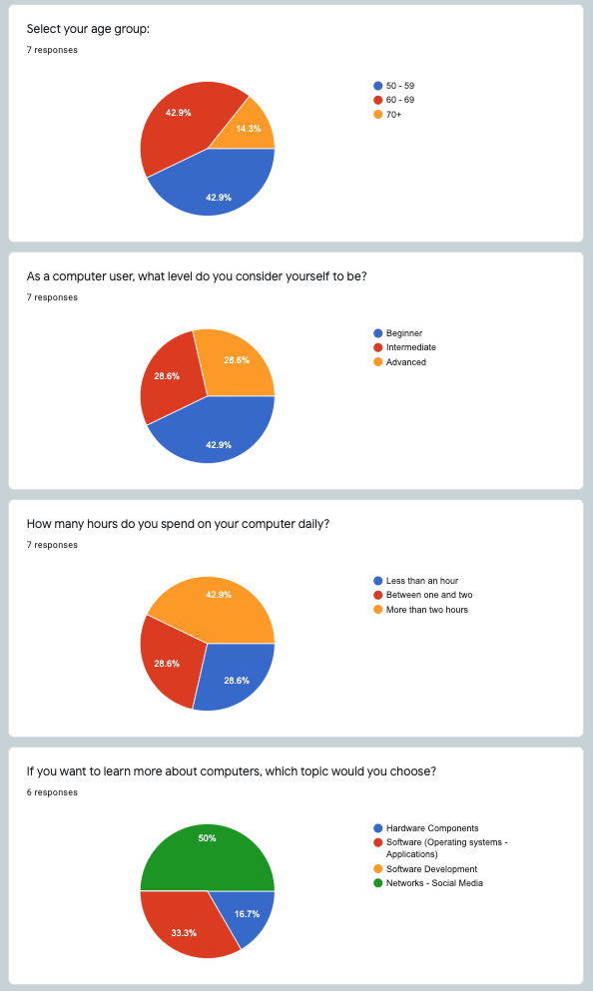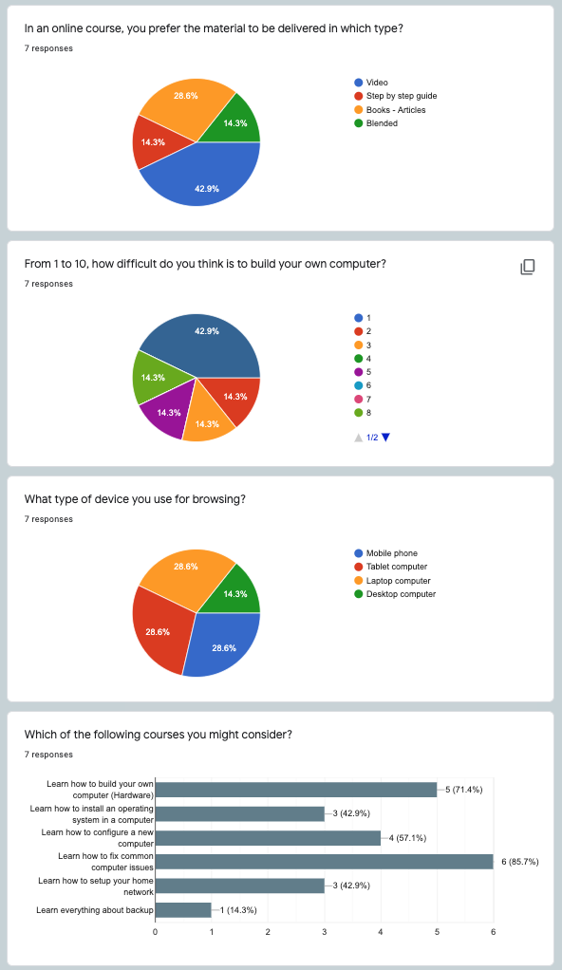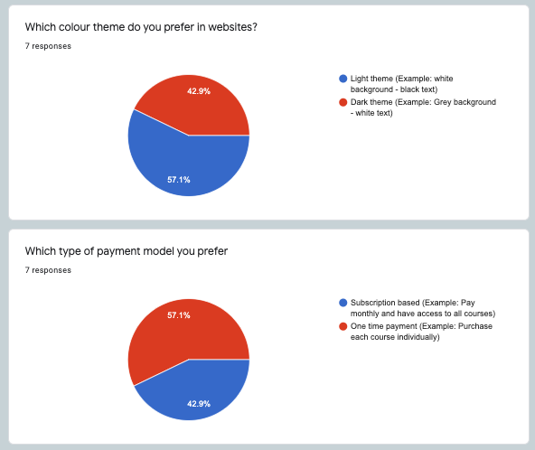

**20.2 Competitors**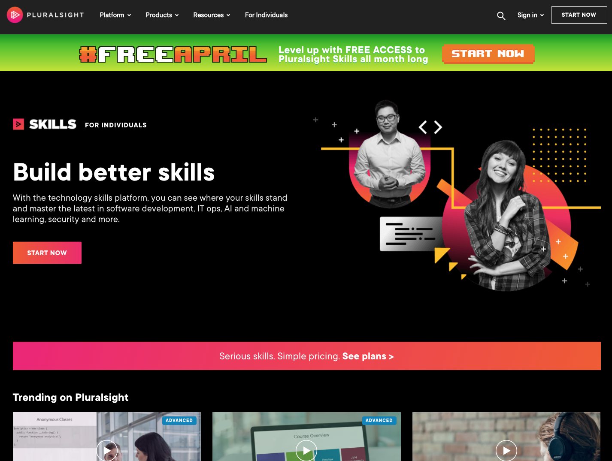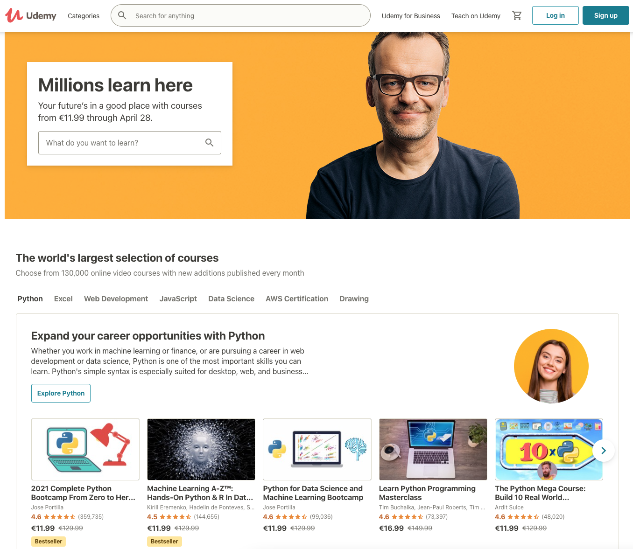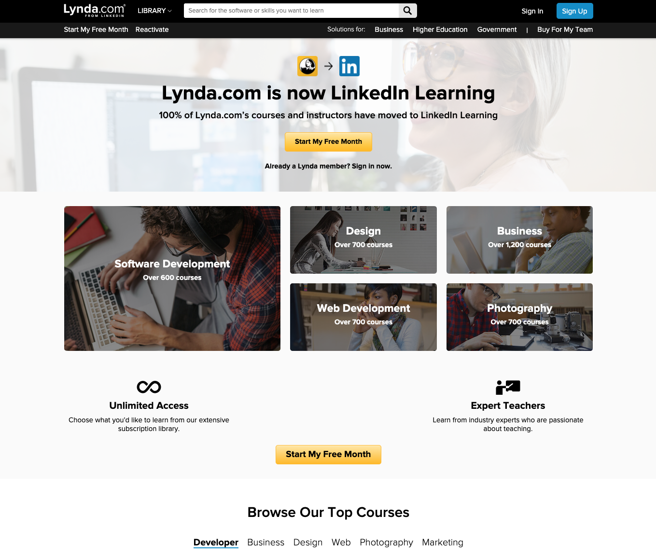

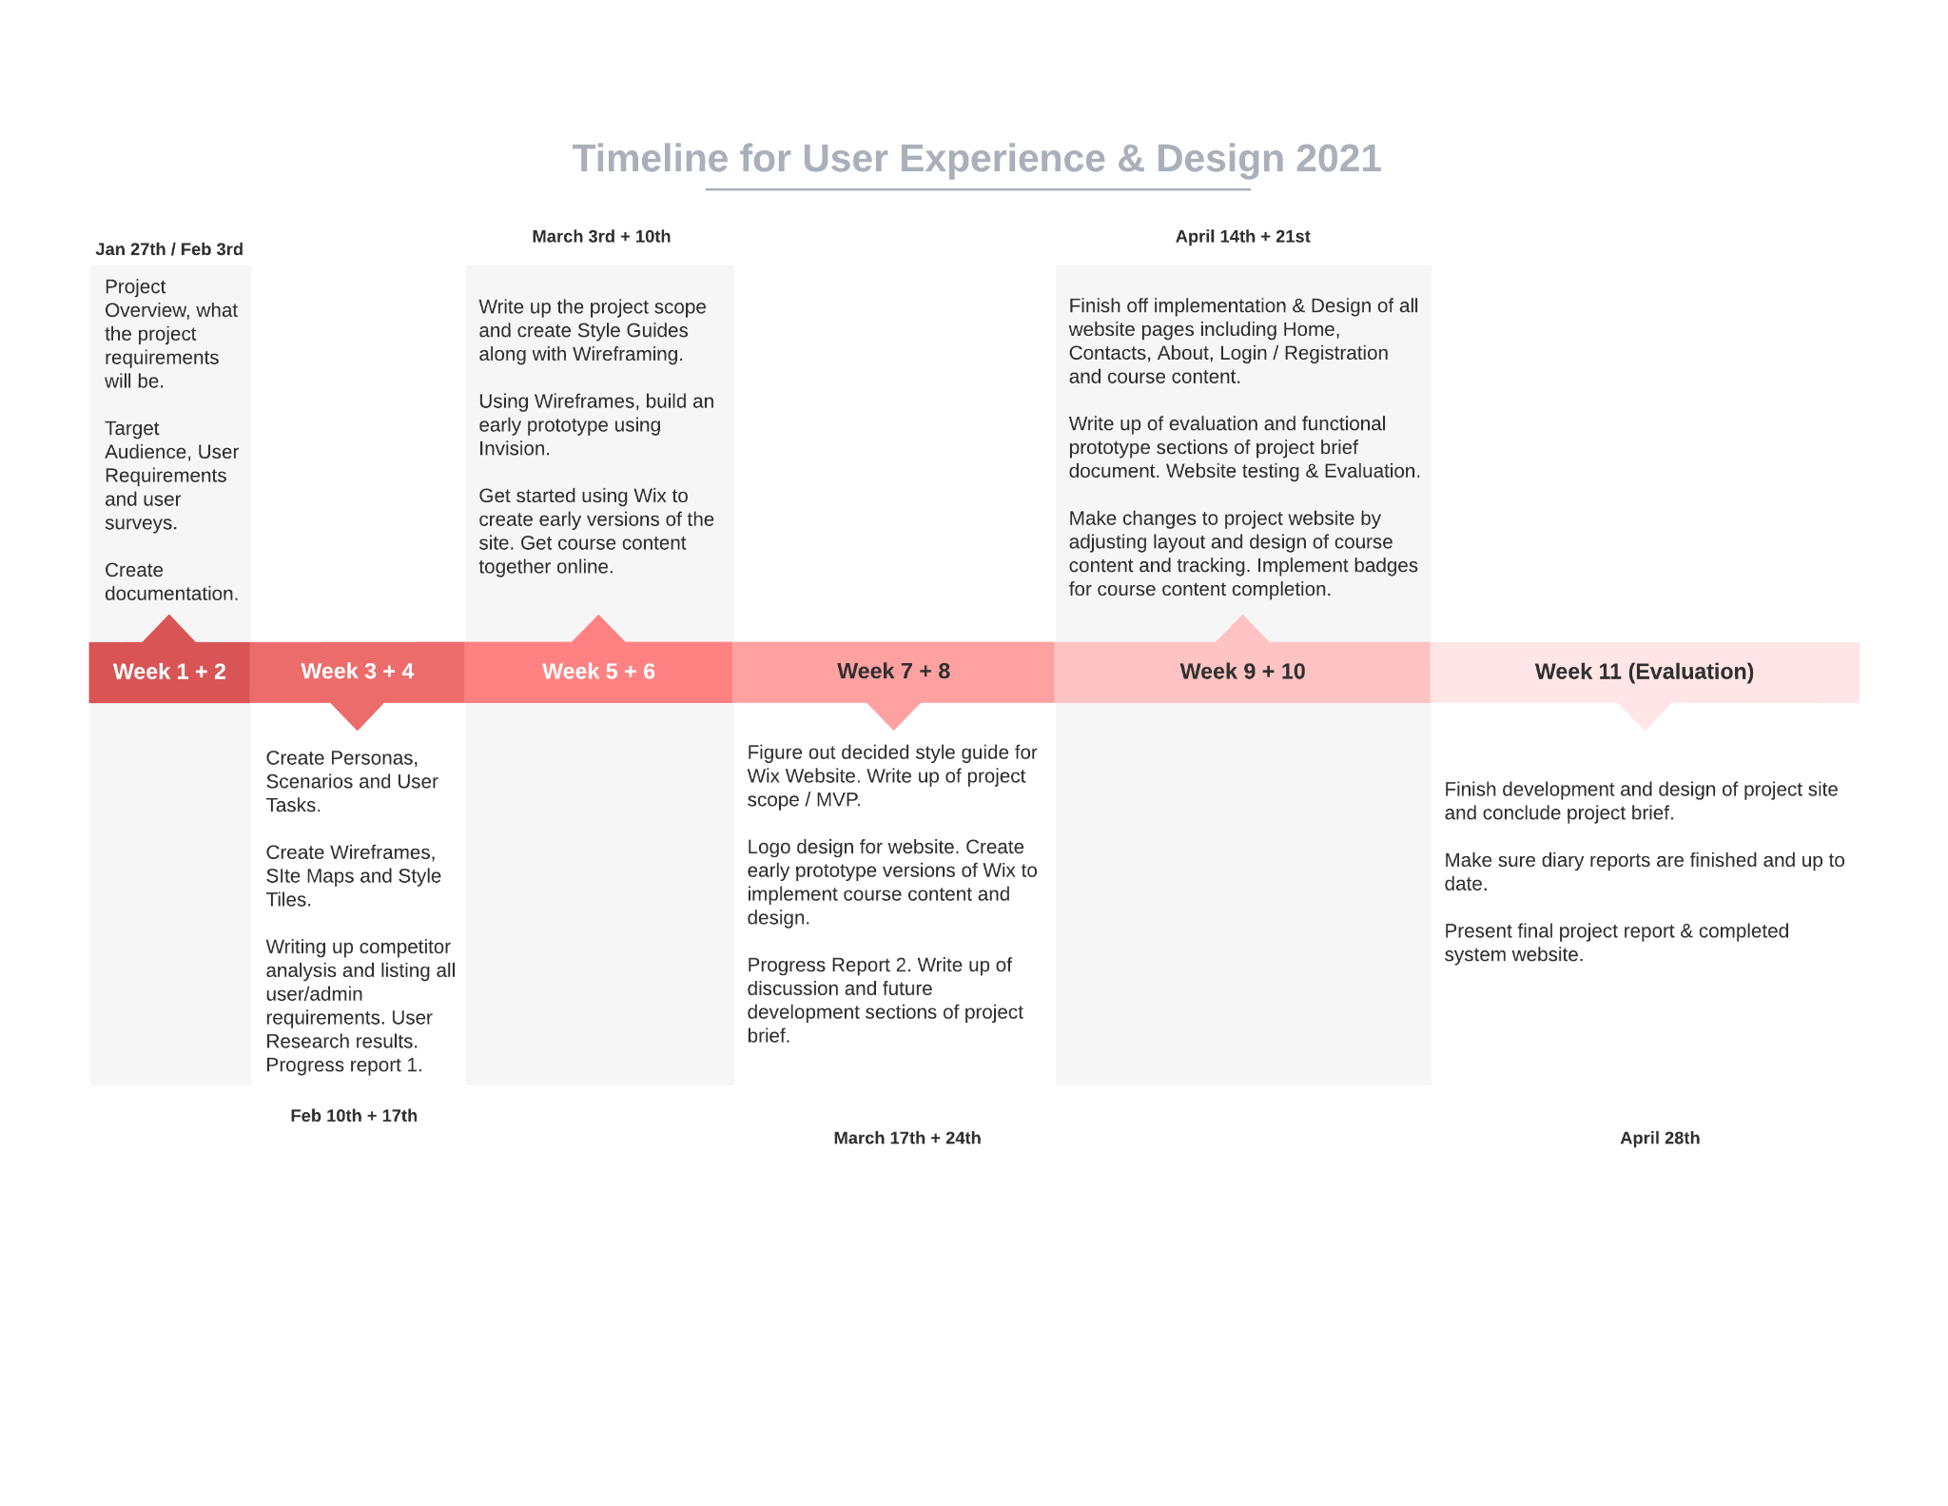**20.3 Timeline Graph**

**20.4 Personas and Scenarios**

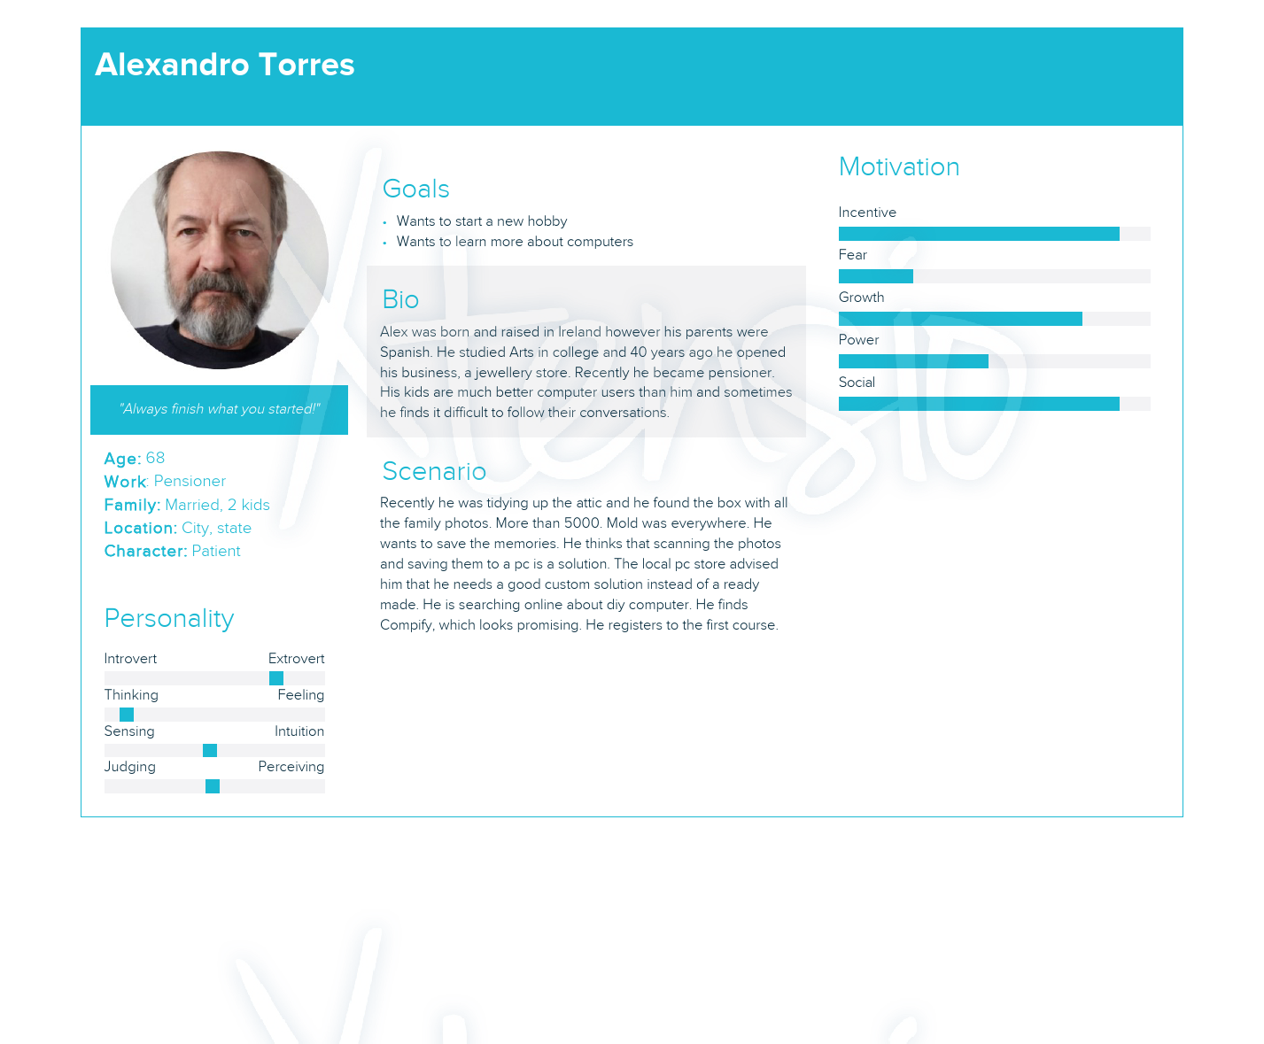

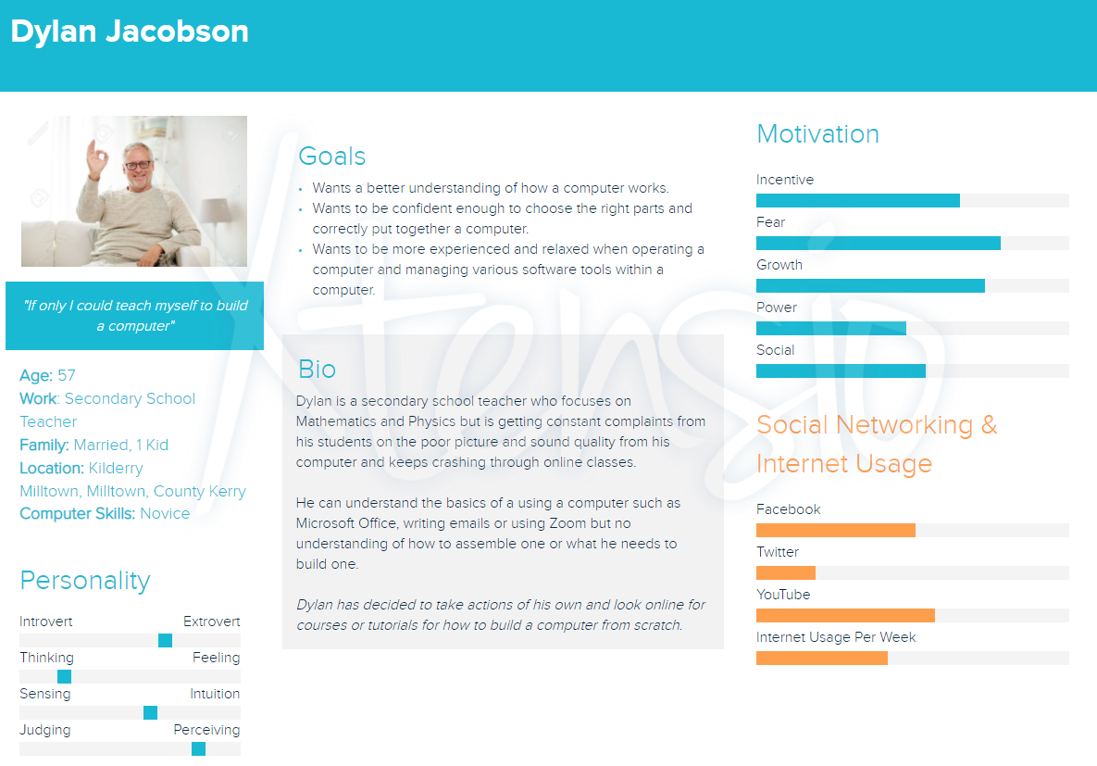

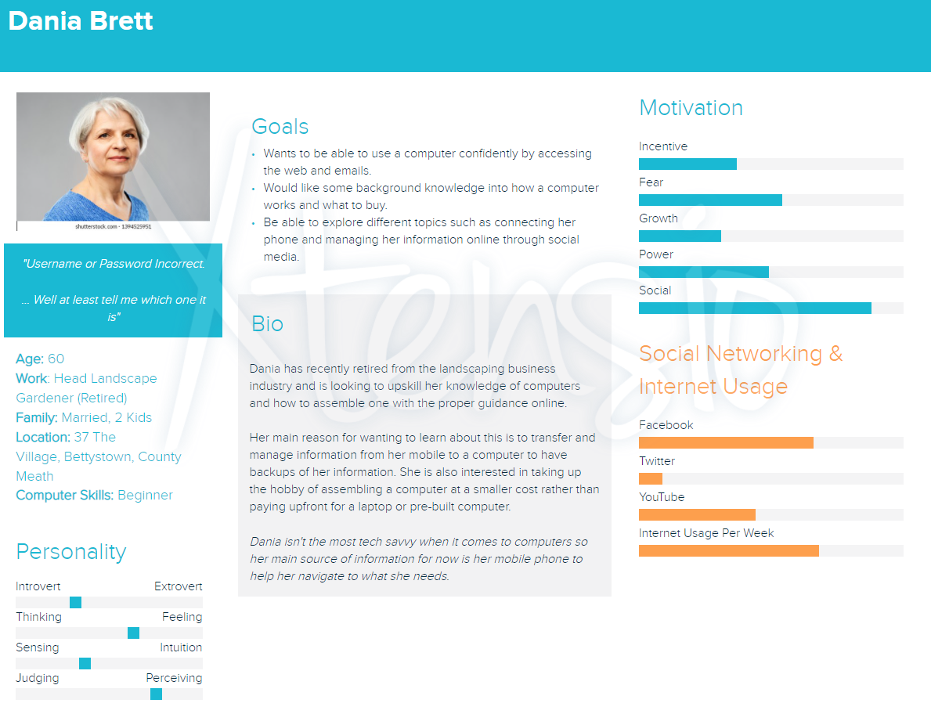

**20.5 Contrast Checker**

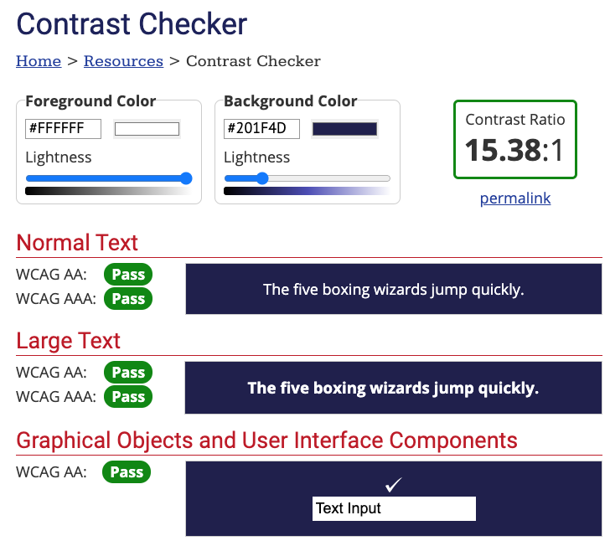

**20.6 Accessibility Report**

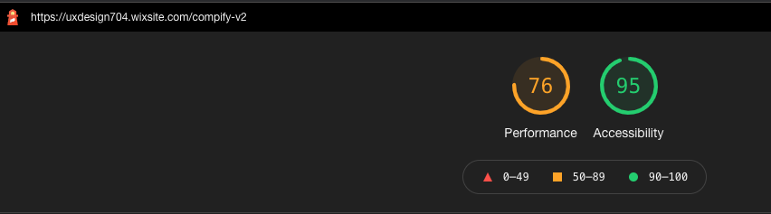

**20.7 Style Tiles**

**Initial version**

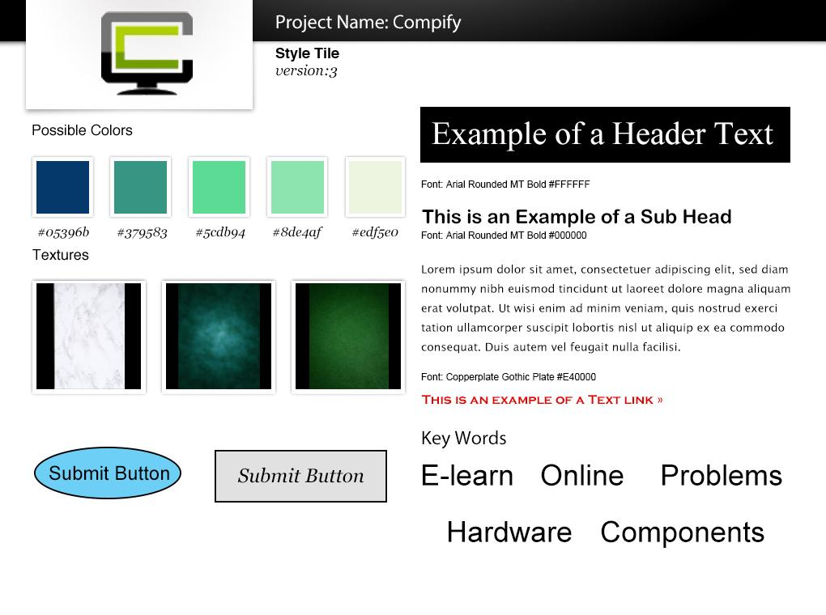

**Updated version**

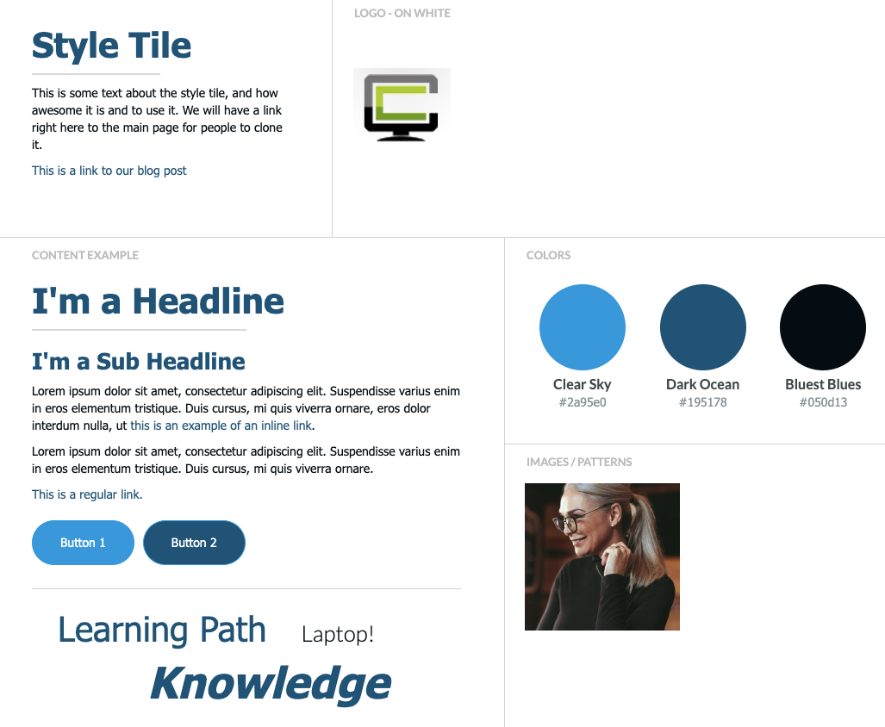

**Final version**

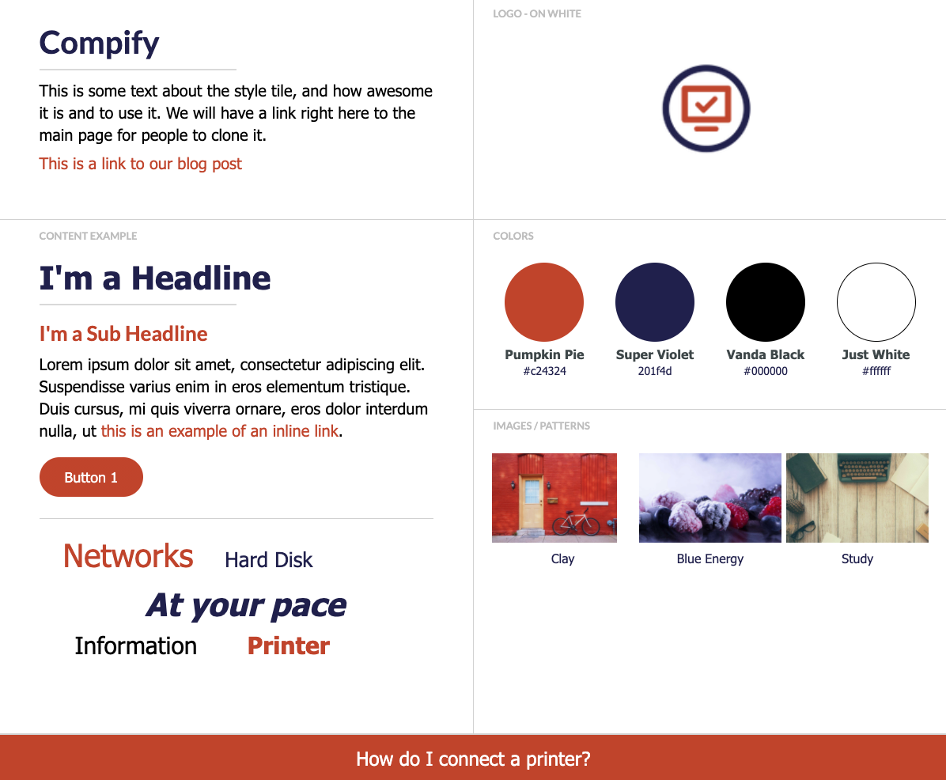

**20.8 Wireframes Desktop**

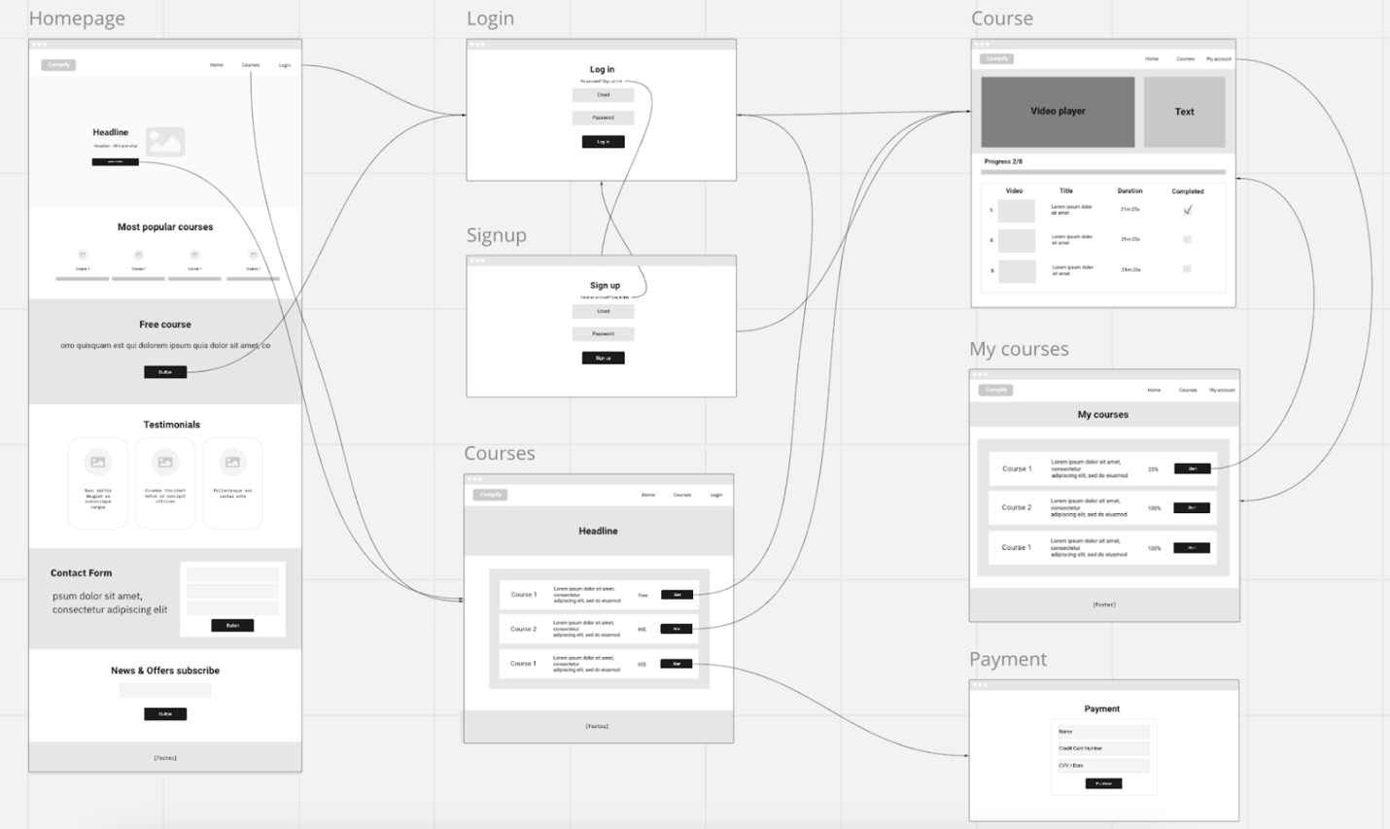

**20.9 Wireframes Mobile**

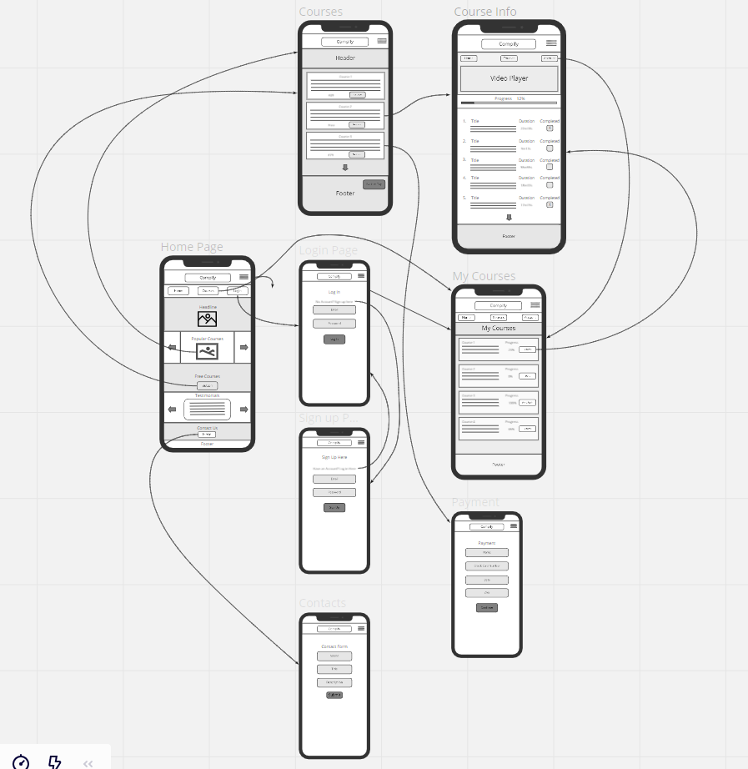

**20.10 Usability Study**

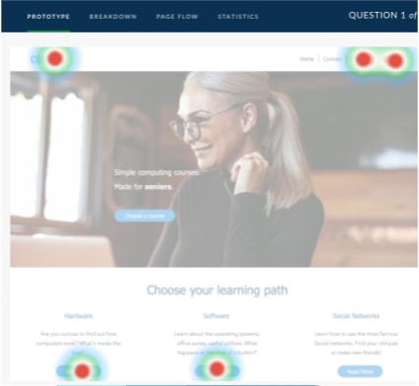

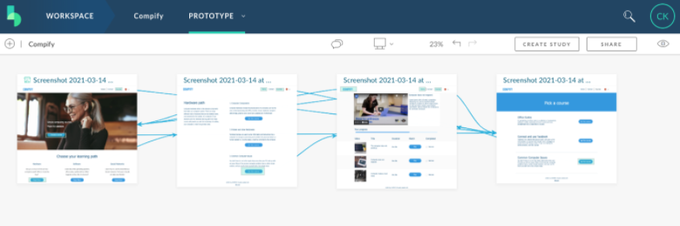

**20.11 Site Map**

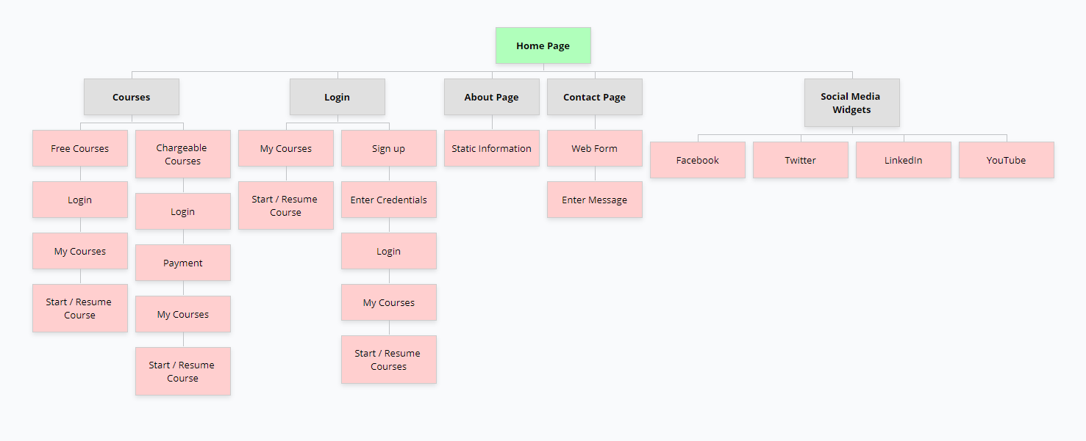

# **21.0 References**

Invision. (2021). *https://www.invision.com*. Retrieved 2021 from Invision: https://www.invision.com

K Y Loh, J. O. (2004). Age related visual impairment in the elderly. *National Library of Medicine*, 59.

Miro. (2021). *https://www.miro.com*. Retrieved 2021 from Miro: https://www.miro.com

Nielsen, J. (1994, 4 24). *https://www.nngroup.com*. Retrieved 4 26, 21 from NNGroup: https://www.nngroup.com/articles/ten-usability-heuristics/

ScienceDirect. (2016). *https://www.sciencedirect.com*. Retrieved 2021 from Sciencedirect: https://www.sciencedirect.com/topics/social-sciences/ageing-population#:~:text=Population%20aging%20is%20the%2021st,to%20rise%20throughout%20the%20world.

Todorovic, D. (2008). *http://www.scholarpedia.org*. Retrieved 4 26, 2021 from Scholarpedia: http://www.scholarpedia.org/article/Gestalt_principles

WebAim. (2021). *https://webaim.org/*. Retrieved 2021 from WebAim: https://webaim.org/

Wikipedia. (2021). *https://www.wikipedia.org*. Retrieved 4 26, 2021 from Wikipedia: https://en.wikipedia.org/wiki/Minimum_viable_product

WIX. (2021). *https://www.wix.com*. Retrieved 2021 from Wix: https://www.wix.com

Xtensio. (2021). *https://xtensio.com/*. Retrieved 2021 from Xtensio: https://xtensio.com/

**22. Online Tools**

* Style tiles created with. <http://styletil.es/>
* Software used to develop wireframes. <https://miro.com/>
* Online tool used to make interactive wireframes as early prototypes for the project website. <https://www.invisionapp.com/>
* Online profile creator used for personas and scenarios. <https://xtensio.com/>
* Contrast checker used. <https://webaim.org/resources/contrastchecker/>
* Timeline Graph template. <https://lucid.co/>
* Interactive Wireframes: <https://markcarley247302.invisionapp.com/console/share/GX29WSRE4C/546633804> ,

<https://christoskoutsiaris153578.invisionapp.com/console/share/34294RJWQK/541055686>